SECTION GH

FUEL INJECTOR

CONTENTS

Chapter

Description .. .. .. .. .. .. .. .. .. 1

Removal and Fitting.. .. .. .. .. .. .. .. 2

Dismantling and Cleaning .. .. .. .. .. .. .. 3

Assembly .. .. .. .. .. .. .. .. .. 4

Testing and Setting .. .. .. .. .. .. .. .. 5

Injector Troubles .. .. .. .. .. .. .. .. 6

Special Tools .. .. .. .. .. .. .. .. .. 7

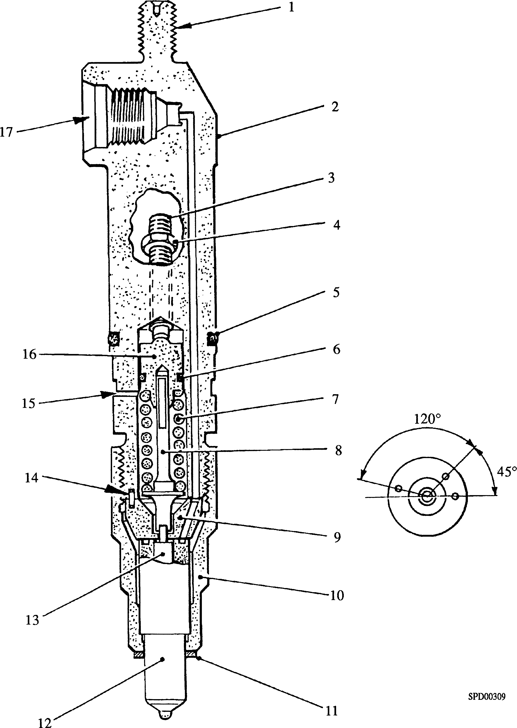

|  |  |  |  |
| --- | --- | --- | --- |
| Key To Numbers  1. Threaded extension for extraction purposes | | 10. | Nozzle nut |
| 2. | Nozzle holder body | 11. | Copper joint washer |
| 3. | Adjusting screw | 12. | Nozzle body |
| 4. | Locknut | 13. | Needle valve |
| 5. | 'O' ring body to injector housing | 14. | Dowel |
| 6. | 'O' ring upper spring plate to body | 15. | Leak-off drilling |
| 7. | Injector spring | 16. | Upper spring plate |
| 8. | Thrust spindle | 17. | Fuel inlet connection |
| 9. | Transfer block |  |  |

Fig GH.l Fuel Injector

CHAPTER 1

DESCRIPTION

1. The fuel-injector consists of two main assemblies:-
2. The holder assembly.
3. The nozzle assembly.
4. The nozzle holder is of the low inertia type, having injector spring (7)(Fig GH.l) at the lower end of the holder, operating nozzle needle valve (13) via thrust spindle
5. . The loading is applied to the spring via adjusting screw (3) and upper spring plate (16).
6. The nozzle assembly consists of nozzle body (12) and needle valve (13). The needle valve is lapped to fit the nozzle body with the finest possible limits at which it will work freely, the ends being reduced in diameter to form stems. The lower stem is ground to a point, the included angle being greater than the seating in the nozzle body to obtain line contact at the top of the body seat.
7. Any fuel leakage between needle valve and nozzle body is conveyed past thrust spindle (8) and through injector spring (7) to leak-off drilling (15), and then through the injector housing, cylinder head and crankcase to a drain rail. Fuel leakage to the adjusting screw is prevented by 'O' ring (6) fitted to upper spring plate (16). The nozzle holder is sealed to the injector housing at its lower end by a copper joint washer (11) and at its upper end by 'O' ring (5).
8. Transfer block (9) is located to nozzle holder body (2) by two dowels (14) ensuring alignment of the fuel inlet drillings and thus reducing turbulence as pressurised fuel passes from the nozzle holder to nozzle body (12).

CHAPTER 2

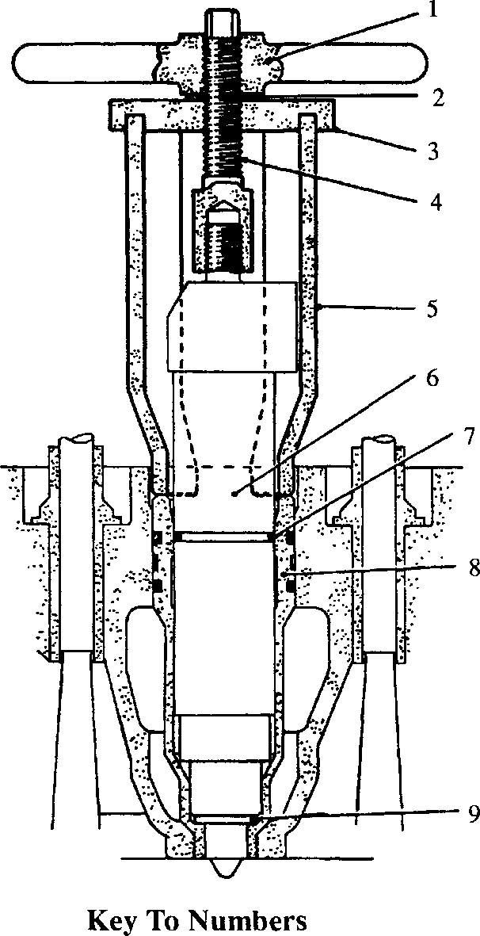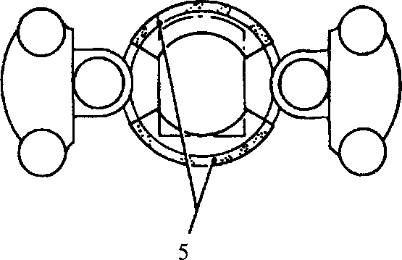REMOVAL AND FITTING

**SPD00303**

1. Handnut
2. Fuel injector
3. 'O' ring
4. Injector housing
5. Copper joint washer
6. Thrust washer
7. Locating plate
8. Extractor stud
9. Front and rear body sections

Fig GH.2 Fuel injector removal tool

Removal

1. Remove fuel injection piping (Section G J).
2. Due to normal carbon deposits, some difficulty may be experienced in removing fuel injectors after the engine has been in service. To facilitate removal, tool (Fig GH.2) has been provided. To remove an injector proceed as follows:-
3. Remove valve gear cover.
4. Release and remove injector securing bolt with washer and clamp.
5. Screw extractor stud (4)(Fig GH.2) on to threaded extension of injector.

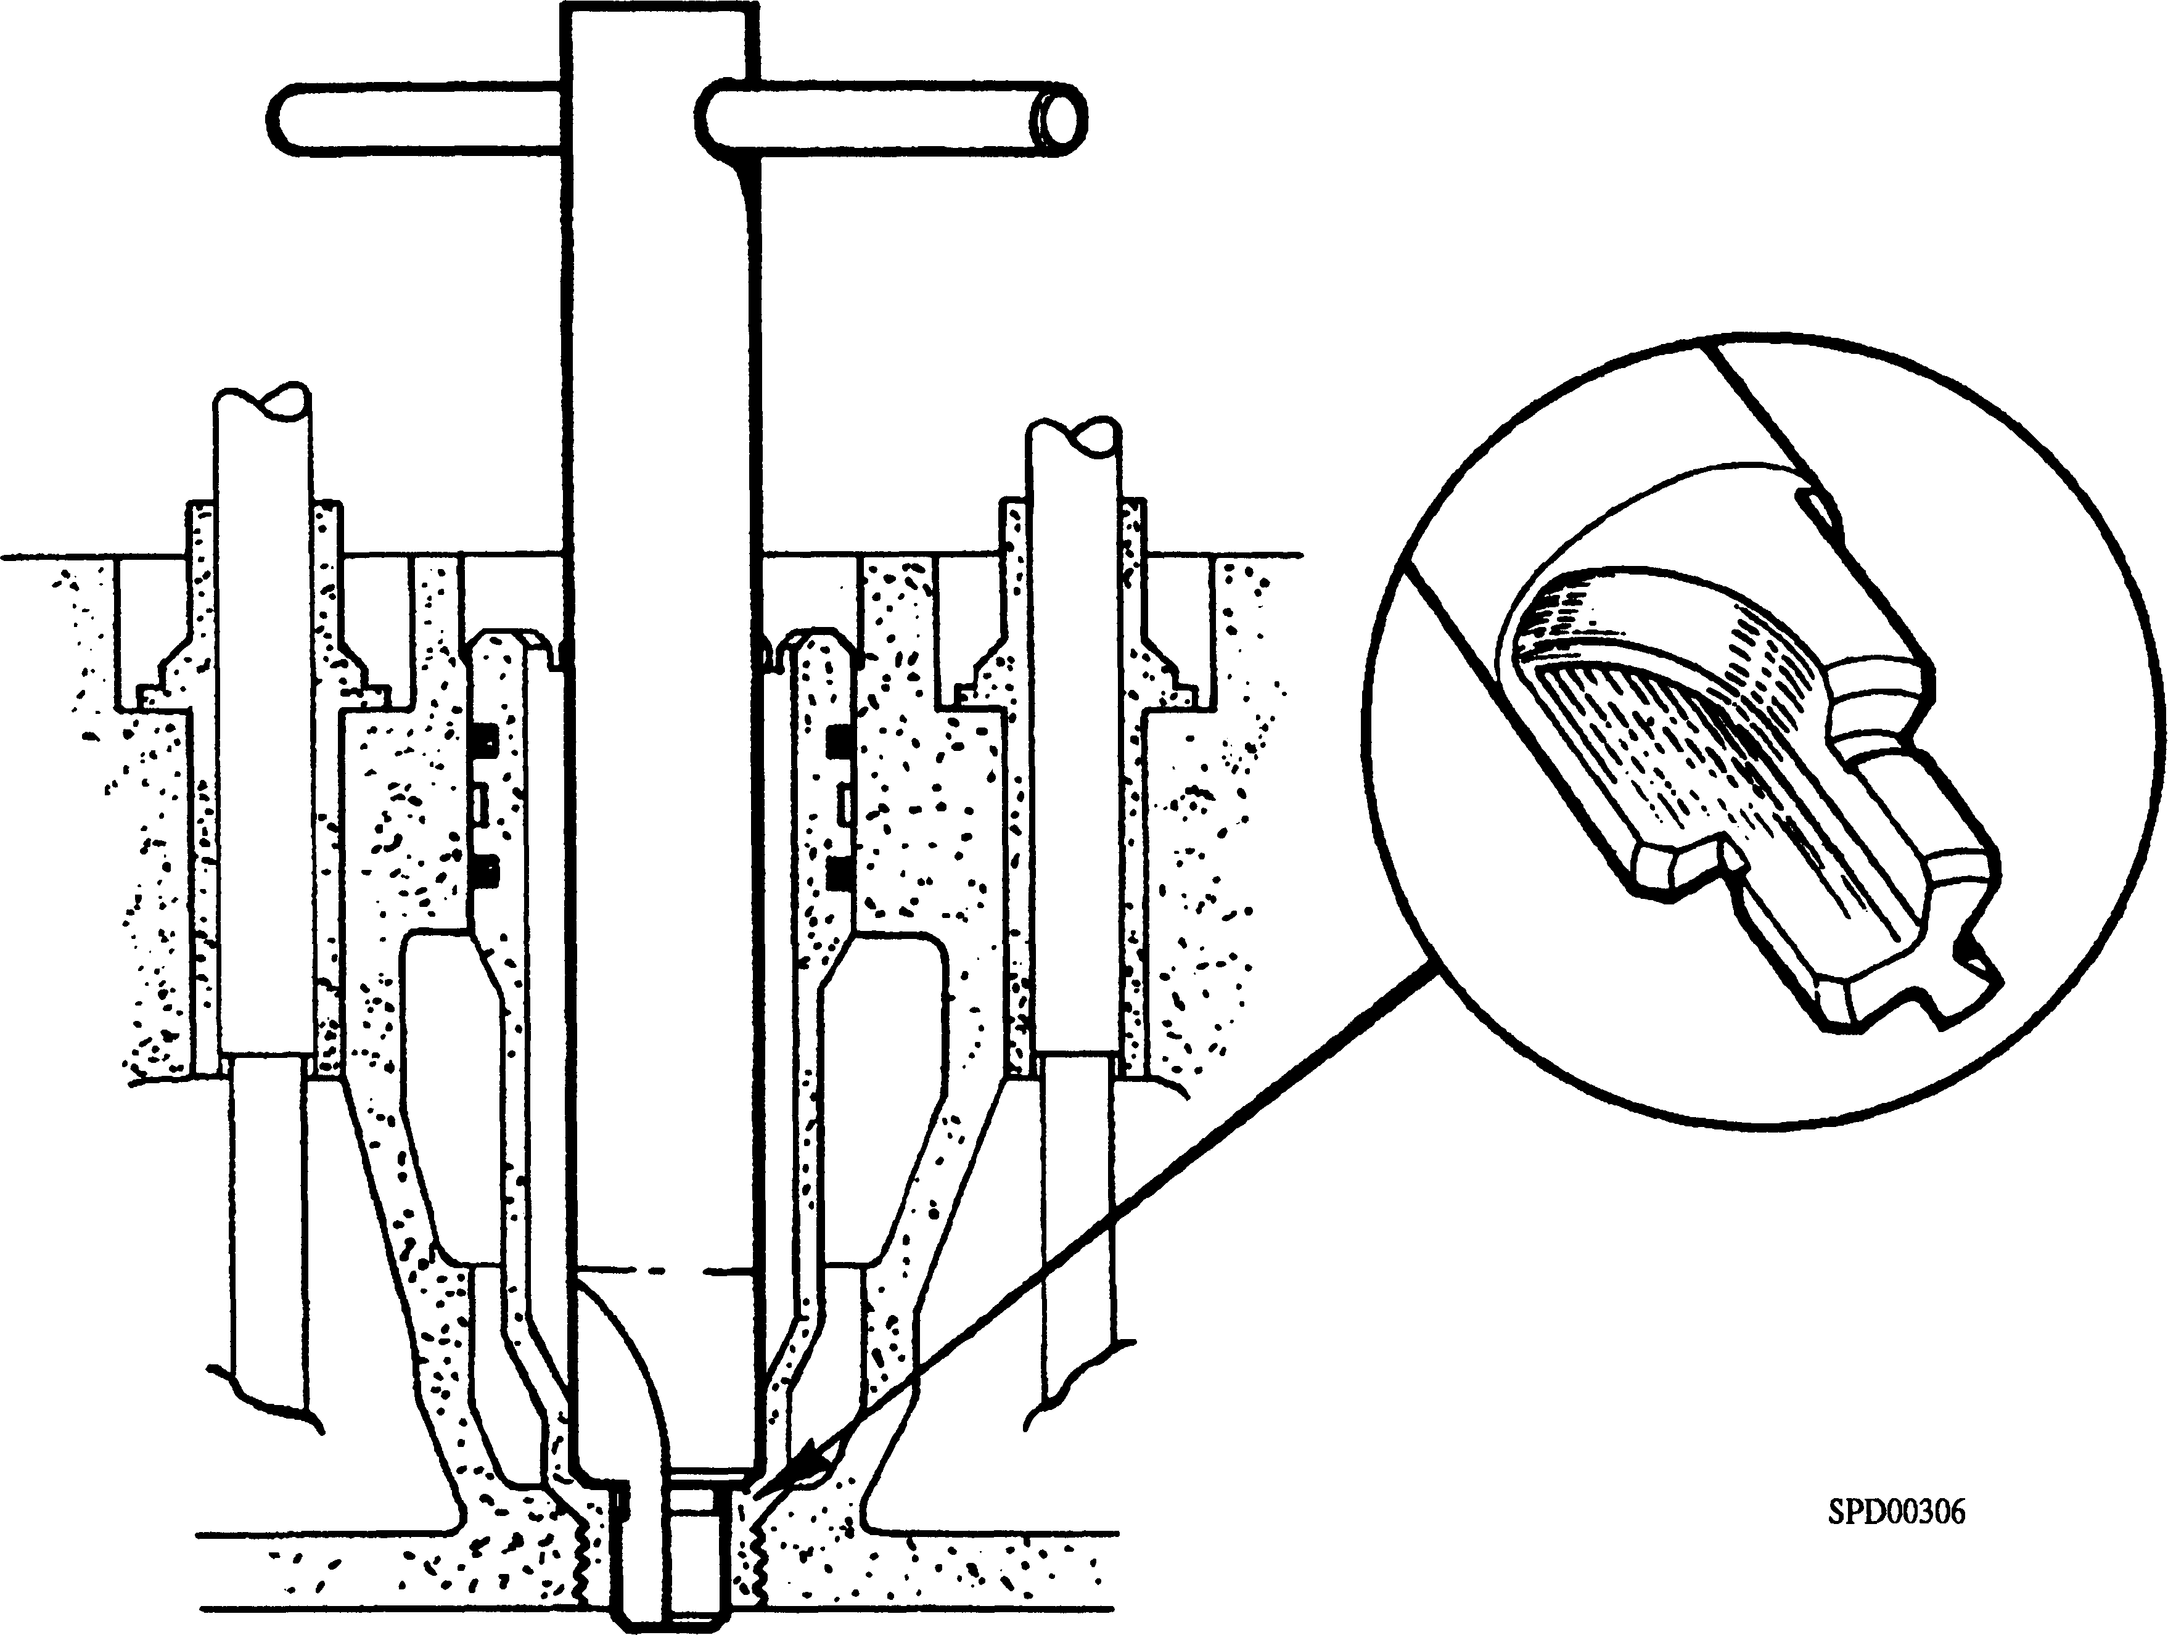

Fig GH.3 Cleaning tool - injector housing

1. Place two body sections (5) of tool in position at front and rear of injector, checking that lower ends seat on injector housing (8). Pass locating plate (3) over extractor stud and engage upper ends of body sections with groove in locating plate.
2. Place thrust washer (2) in position and screw on hand nut (1). Tighten hand nut to withdraw injector. It will be necessary to use withdrawal tool until injector 'O' ring (7) is clear of injector housing (8).
3. Support body sections (5) and lift out injector, extractor stud, locating plate and hand nut. Remove body sections. Remove hand nut and locating plate and unscrew extractor stud from injector.
4. Remove injector joint washer (9). The washer may come away with the injector or remain in injector housing.
5. Blank off injector leak-off connection with sealing tape and fuel inlet with a protective plug.

Fitting

1. Remove all carbon from injector housing, with particular reference to sealing face at bottom of housing, using tool (Fig GH.3). DO NOT use excessive pressure as this may result in damage to the housing.
2. Fit a new 'O' ring (5)(Fig GH.l) to injector body.
3. Clean all carbon from copper joint washer (11), anneal if necessary or use a new joint washer, and fit to injector. A light film of grease on joint face of nozzle nut
4. will hold joint washer in position whilst fitting injector.
5. Remove blanking plug and sealing tape from injector.
6. Lower injector into cylinder head until body 'O' ring is in contact with injector housing. Align injector inlet aperture with aperture in intermediate cover and press injector into position. Confirm alignment by passing injector nut through intermediate cover aperture and screwing it into injector body. A certain amount of angular alignment of the injector may be required.
7. Place injector clamp, washer and clamp bolt in position and tighten bolt to torque loading quoted in Section CE. Care should be taken when positioning injector clamp to ensure that clamp toe does not foul rocker lever fulcrum brackets.
8. Pour a small quantity of lubricating oil into recess formed in top deck of cylinder head by injector housing and injector.
9. Disconnect injector drain piping from drain rail and connect a suitable air supply. Raise pressure in injector drain system to 0.7 - 1.5 bar and check for leaks. Leakage from drain rail connections will be audible, whilst leakage past injector/injector housing 'O' ring will be indicated by bubbles in the lubricating oil.
10. Rectify any leaks and retest.
11. Disconnect and remove air test equipment and re-connect drain piping.
12. Refit fuel injection piping (Section GJ).
13. Fit valve gear cover.

CHAPTER 3

DISMANTLING AND CLEANING

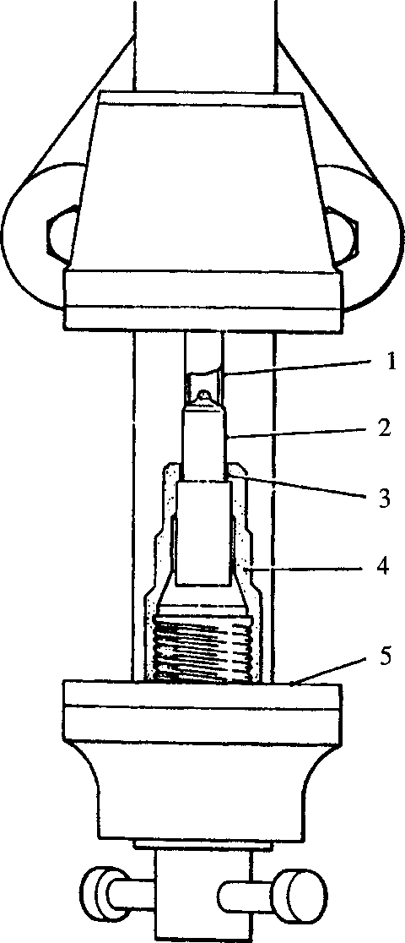Key To Numbers

1. Copper or brass tube
2. Nozzle body
3. Carbon deposit area
4. Nozzle nut
5. Vice

Fig GH.4 Nozzle body removal from nozzle nut

NOTE Injector dismantling, servicing and testing should only be carried out where suitable test equipment is available.

General

1. Injector dismantling and assembly must be carried out under dust free conditions on a bench used specifically for this purpose. The bench should be covered with zinc or linoleum and be provided with a suitable vice equipped with copper or zinc grips.

Dismantling

NOTE Before dismantling injectors which are in a very dirty condition externally, inlet connection and leak-off drilling should be blanked off and injectors thoroughly washed in clean fuel oil.

1. Brush nozzle externally with a brass wire brush to remove all carbon deposits.
2. Hold injector horizontally in a vice, adjusting screw uppermost, and using a 13 mm A/F spanner, slacken adjusting screw locknut (4)(Fig GH.l). Using a 6 mm A/F wrench key, unscrew and remove adjusting screw (3).
3. Using a 32 mm A/F spanner, release and remove nozzle nut (10). Remove nozzle assembly, transfer block (9), thrust spindle (8) and spring (7). DO NOT remove dowels (14) other than for renewal.
4. Using a soft bar through adjusting screw tapping, push out upper spring plate (16).
5. Remove needle valve (13) from nozzle body (12) and remove nozzle body from nozzle nut (10). Due to carbon deposits, it may be necessary to PUSH nozzle body out of the nut. This should be done using a length of copper or brass tubing (Fig GH.4). The nozzle body MUST NOT be driven out by striking body end face or tip.

Cleaning and Checking

1. The special tool kit (Fig GH.5) designed to enable quick and safe servicing of the nozzle assembly MUST always be used. On no account should tools other than those described here be used or serious damage to the nozzle body and needle valve may result.
2. Abrasives and metal polish MUST NOT be used on the nozzle body and needle valve.
3. Before commencing cleaning operations it is essential to see that the bench is perfectly clean and that ample supplies of CLEAN fuel oil are available.

NOTE The nozzle body and needle valve are mated pairs and components CANNOT be interchanged. For this reason it is recommended that only ONE nozzle assembly is dealt with at a time.

1. Wash and clean all parts of nozzle holder assembly with clean fuel oil paying particular attention to nozzle nut clamping shoulder. Remove any carbon deposit with a scraper. Care must be taken not to scratch the shoulder.
2. Examine mating faces of nozzle holder body and transfer block. These must be perfectly clean, flat and smooth. If any signs of staining or fretting are apparent or the performance of the injector is suspect the following test should be carried out.
3. Fit dowel (14)(Fig GH. 1) to transfer block (9), locate transfer block with dowels (14) to nozzle holder body (2) and secure in position using nozzle nut
4. and a dummy nozzle. The dummy nozzle is a special test piece consisting of a nozzle machined externally but without fuel drillings.
5. Tighten nozzle nut to a TORQUE LOADING OF 80Nm (601bf.in2)

NOTE This torque loading is for test only and is not the final assembly torque loading.

1. Connect injector to test pump using High Pressure Pipe Assembly and raise pressure to 276 bar. THERE SHOULD BE NO BACK LEAKAGE.
2. If back leakage is observed, remove dummy nozzle and lap the mating faces of holder and transfer block using lapping plate and Hartridge Fine Lapping Compound. DO NOT LAP THE TWO FACES TOGETHER.
3. It is recommended that holder is mounted in a vice, mating face uppermost and lapping plate laid on the face, whilst transfer block may be lapped in a normal manner after removing dowels. If mating faces are excessively distorted, one or both items should be renewed.
4. Examine injector spring. If rusty or damaged in any way it should be renewed.

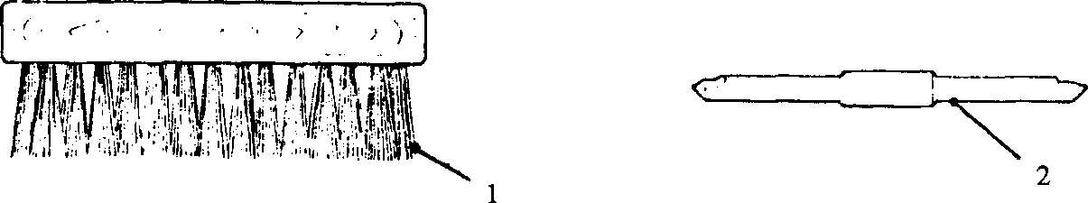image168Key To Numbers

3.14

3.15

3.16

3.17

3.18

3.19

3.20

3.21

3.22

3.23

3.24

4

3

**SPD00304**

1. Brass wire brush 3. Tool for holding spray hole wire
2. Nozzle body seat cleaning tool 4. Fuel chamber scraper

Fig GH.5 Nozzle cleaning tools

Examine thrust spindle and upper spring plate for wear and damage. Check that spindle slides smoothly in bore of spring plate. Renew either or both items if wear or damage is observed.

Examine adjusting screw and locknut for serviceability. Renew if threads are distorted.

Allow needle valve and nozzle body to soak in clean fuel oil for a short period. Withdraw needle valve from nozzle body and examine guide surface. This should be bright and free from high spots, scratches and dull areas. Lightly brush valve seating with a brass wire brush until bright metal is visible over the whole area.

Needle lift, in nozzle body, measured with needle gauge should be from 0.44 mm to 0.6 mm for new assemblies, if lift is greater than 0.75 mm a new nozzle assembly should be fitted.

If needle valve is discoloured or high spots, scratches or dull areas are visible, the complete nozzle assembly should be returned to BRYCE BERGER LTD., or to an approved agent for examination and reconditioning.

Examine nozzle body joint face. This should be perfectly clean flat and smooth.

Examine nozzle valve stem boring. This should be bright and free from high spots, scratches and dull areas. Check that needle valve slides smoothly in bore.

Clean out fuel passages in nozzle body with brass wire of suitable diameter.

Insert fuel chamber scraper (4)(Fig GH.5) into nozzle body until nose locates in fuel gallery. Press against side of gallery and rotate to clear any carbon or other deposits.

Insert seat scraper (2) and clean all carbon from valve seat by rotating and pressing tool on to seating.

Prick out holes in end of nozzle body with a short piece of wire of the CORRECT DIAMETER, holding it by means of wire holder (3). Extreme care must be taken to prevent the danger of wire breaking in the hole as such particles are almost impossible to remove. If difficulty is experienced cleaning out the holes due to hardness of carbon, it is recommended that the nozzle assembly is returned to BRYCE BERGER LTD., or to an approved agent for attention.

LIMITED RIGHTS LEGEND

USE, DUPLICATION OR DISCLOSURE OF THIS INFORMATION WHICH IS THE PROPERTY OF GEC DIESELS LIMITED BY THE U.S. GOVERNMENT OR BOLLINGER IS SUBJECT TO THE RESTRICTIONS SET FORTH IN DOD FAR SUPP 252.227-7013 (a) 15.

1. When using wire holder, cleaning wire should be fitted to tool chuck so that it only protrudes for about 1.5 mm, thus giving maximum resistance to bending. Enter wire into spray hole, pushing and rotating gently until hole is cleared.
2. Thoroughly wash away all carbon from interior of nozzle body using nozzle multiclean. Then blow clean. Wash body backward through spray holes with clean fuel oil under pressure from test pump.
3. Examine seat closely under a strong light to ensure that all traces of foreign matter have been removed.

Nozzle Flow Test

1. Any flow testing carried out must be on equipment calibrated from reference nozzles supplied by PAXMAN DIESELS LTD. These are:-

OD30007 - Datum nozzle high limit - colour code RED

OD29758 - Datum nozzle Low limit - colour code BLUE

If the needle or nozzle seatings are badly marked, the nozzle and needle valve must be renewed as an assembly.

3.29

3.30

3.31

3.32

1. A dry air supply at a pressure of 5.5 - 7 bar is required for drying nozzles and for supplying the flow rig.

***NOTES***

1. A small TRICHLOROETHANE vapour unit, mounted in a ventilated cupboard is required for degreasing nozzle bodies.
2. Each nozzle body must be degreased before flow testing as a film of fuel oil in the nozzle spray holes will give a false reading.
3. As degreasing with TRICHLOROETHANE removes the protective coating from both internal and external surfaces, the body should be degreased, flow tested and immediately placed in a bath of clean fuel oil to prevent rusting.

Check air pressure setting of flow test rig (Fig GH.6) by disconnecting the pipe between flow meter (5) and nozzle mounting clamp (9) at back plate (11) and connecting the the pipe directly to a 'MASTER' pressure gauge. Turn on air supply cock (2) and, if necessary, adjust pressure regulator (3) to obtain a pressure of 0.7 bar. Remove the pressure gauge and re-connect the pipe to back plate (11).

Using the TRICHLOROETHANE vapour unit, degrease both 'HIGH' and 'LOW' flow datum nozzles, directing the fluid from the condensing coils into the nozzle body bore, allowing the bore to fill and flow over the external surfaces.

Drain nozzle bodies and dry the internal and external surfaces using dry compressed air.

1. Using operating handle (10), retract slider (15), place the 'HIGH FLOW DATUM' nozzle in position against backplate (11) ensuring that it locates firmly against 'O' ring (16) and release the handle to allow the slider to return and clamp the nozzle body in position.
2. Turn 'ON' air supply cock (2), allow 10-15 seconds for the air flow through the nozzle to stabilise and set upper indicator ring (7) to the flow rate shown by floating regulator (4) in flow meter tube (6).

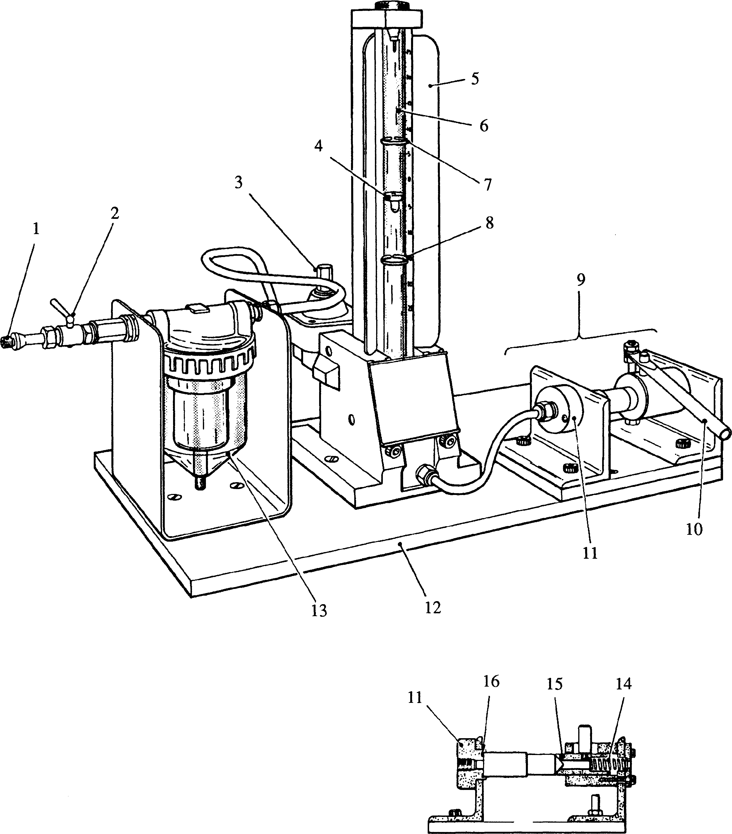

SECTION THROUGH NOZZLE MOUNTING CLAMP

**SPD00308**

**Key To Numbers**

|  |  |  |  |
| --- | --- | --- | --- |
| 1. | Air supply connection | 9. | Nozzle mounting clamp |
| 2. | Air supply cock | 10. | Operating handle |
| 3. | Pressure regulator | 11. | Back plate |
| 4. | Floating regulator | 12. | Base plate |
| 5. | Flow meter | 13. | Air filter |
| 6. | Flow meter tube | 14. | Spring |
| 7. | Upper indicator ring | 15. | Slider |
| 8. | Low indicator ring | 16. | 'O' ring |

**Fig GH.6 Nozzle flow test rig**

1. Repeat Paras 3.33 and 3.34 using 'LOW FUEL DATUM' nozzle and set low indicator ring (8).
2. Remove the needle valves and degrease the nozzles to be tested as described in Paras 3.31 and 3.32. Fit each nozzle to the flow test rig, turn 'ON' air supply cock (2) and check flow rate (floating regulator (4) will be between indicator rings (7) and (8) for nozzles within the required flow limits). Referring to NOTE 4, place the body in a bath of clean fuel oil and refit correct needle.
3. A 'LOW' flow rate indicates that one or more of the spray holes are blocked. These should be cleaned, the nozzle body washed and retested as described above.
4. A 'HIGH' flow rate indicates worn spray holes and the nozzle assembly should be renewed. Reclamation is not possible.

CHAPTER 4

ASSEMBLY

1. Thoroughly wash all parts in clean fuel oil and bring together without wiping.
2. Fit new 'O' ring (6)(Fig GH.l) to upper spring plate (16),and insert into nozzle holder body (2). Push spring plate up body bore as far as possible.
3. Fit locknut (4) to adjusting screw (3) and screw into body until it just touches spring plate.
4. Mount holder in a vice, nozzle end uppermost and fit spring (7) and thrust spindle (8). Ensure that stem of thrust spindle engages with bore of upper spring plate.
5. Apply a light coating of fuel oil to nozzle body clamping shoulder. This will lubricate clamping shoulder of transfer block and nozzle body whilst tightening nozzle nut.
6. Assemble needle valve (13) to nozzle body (12), push dowel (14) into small hole in transfer block (9), locate upper stem of needle valve into transfer block, invert assembly. Ensure that needle valve stem engages with thrust spindle (8) and dowel in transfer block locates with blind hole in nozzle holder body (2).
7. Fit nozzle nut (10) and tighten to torque loading quoted in Section CE.

CHAPTER 5

TESTING AND SETTING

WARNING WHEN TESTING INJECTORS, CARE MUST BE TAKEN TO PREVENT HANDS FROM CONTACTING THE SPRAY, AS THE WORKING PRESSURE WILL CAUSE FUEL OIL TO PENETRATE THE SKIN, NECESSITATING IMMEDIATE HOSPITAL TREATMENT. THE SPRAY IS ALSO FLAMMABLE.

TEST OILS The recommended test oils are Shell Calibration Fluid 'C' or 'B' or equivalent fluids (Viscosity, Redwood No.l 38 seconds at 100°F). DO NOT use diesel fuel oil.

Back Leakage

1. The measurement of back leakage is dependent upon the trapped volume of the test pump system. The standard on which the following figures are based is that a change in trapped volume of 45 ± 1 Hartridge Units will produce a change in indicated pressure of 51 bar.
2. All Hartridge Test Pump Units are normally supplied set to this figure including the recommended unit.

Setting Up Injector For Testing

1. Place injector for testing loosely in jaws of quick action clamp (15)(Fig GH.7) and connect high pressure pipe (3) to fuel inlet connection (17)(Fig GH.l). Adjust clamp on inclined support (14)(Fig GH.7) to position injector nozzle tip just inside spray chamber (1). Tighten clamp and all pipe connections.

NOTE 1 The fuel control valve when closed completely isolates pump from injector for testing. The degree of opening restricts the amount of test oil which can be delivered to the injector.

2 The gauge isolator when closed isolates pressure gauge from high pressure circuit, which eliminates the damping effect of the gauge and will prevent damage to it when testing for atomisation and chatter. If pressure SHOULD become trapped in the gauge, release gauge isolator a very small amount to let the pressure fall slowly. Only fingertip pressure is required to operate both this control and the fuel control valve.

1. Pressure Setting
2. Close gauge isolator.
3. Open fuel control valve one full turn.
4. Switch on extractor fan.
5. Operate hand lever smartly until all air is expelled from the injector.
6. Close fuel control valve and set its pointer to 'ZERO', then open valve the minimum amount that will allow injector to operate when pressing down hard on the hand lever. Note reading on scale.

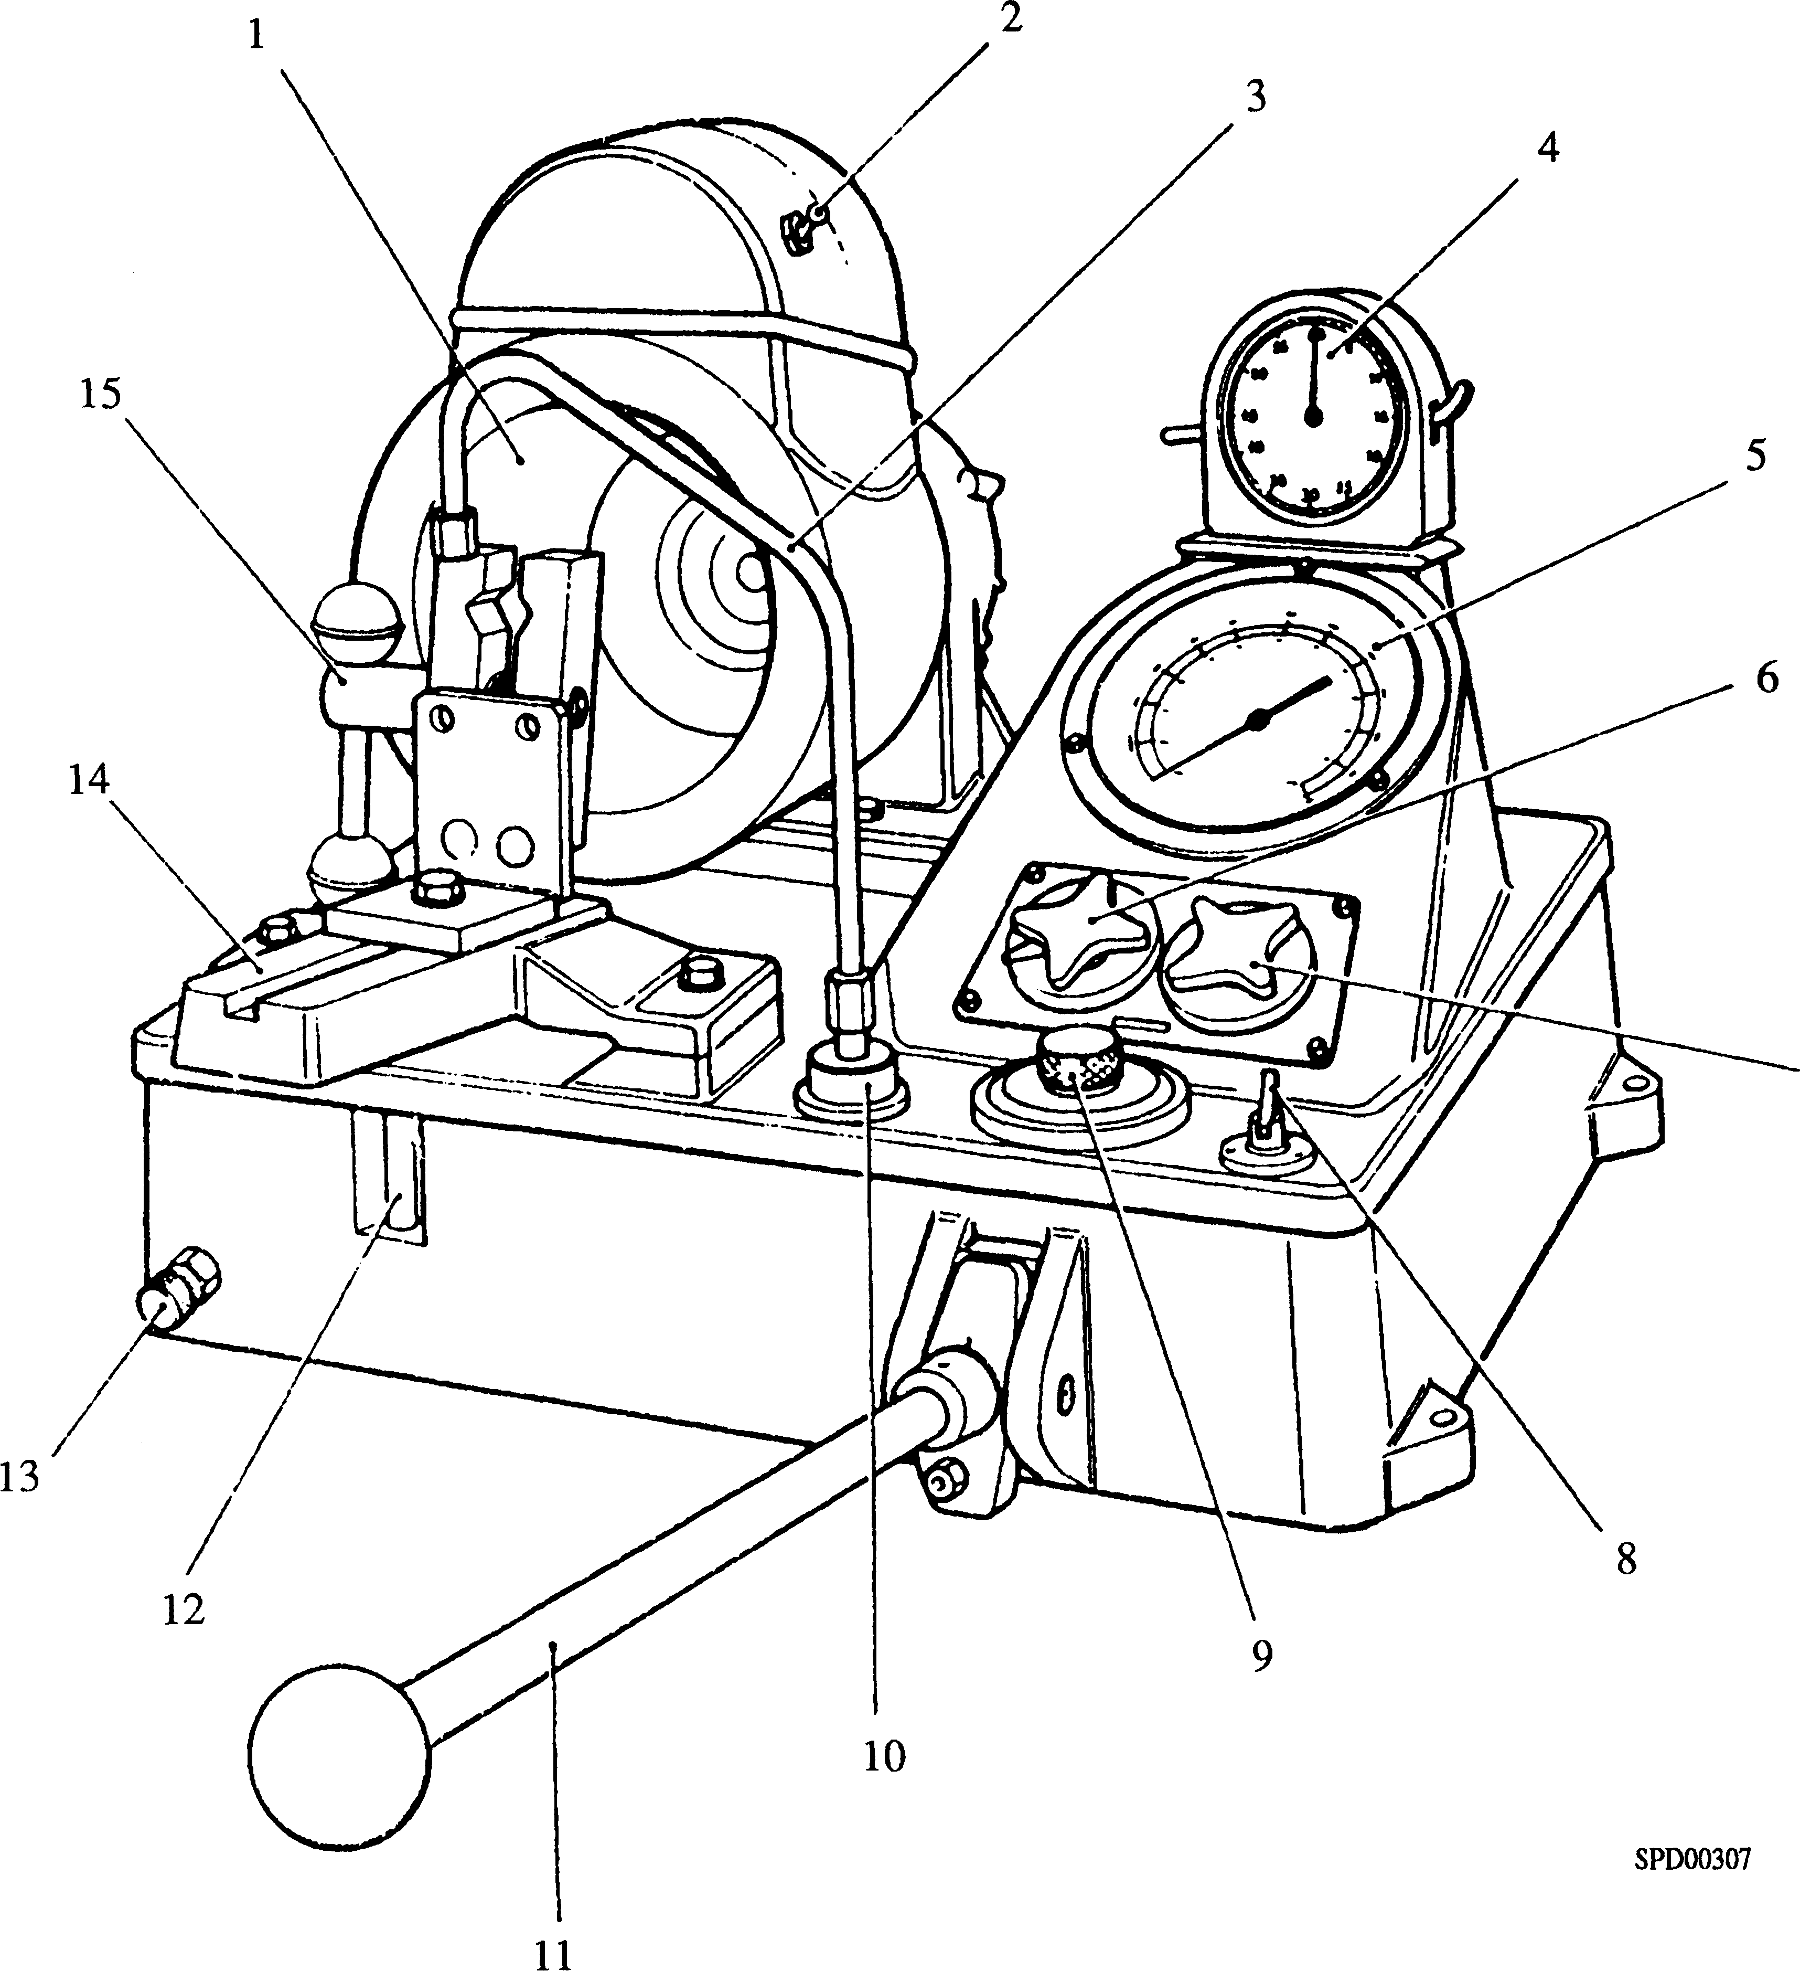

**Key To Numbers**

|  |  |  |  |
| --- | --- | --- | --- |
| 1. | Illuminated spray chamber | 9. | Filler cap |
| 2. | Light switch | 10. | Fuel outlet |
| 3. | High pressure pipe | 11. | Hand lever |
| 4. | Clock | 12. | Sight tube |
| 5. | Pressure gauge | 13. | Tank drain |
| 6. | Fuel control valve | 14. | Inclined support |
| 7. | Gauge isolator | 15. | Quick action clamp |
| 8. | extractor fan switch |  |  |

**Fig GH.7 Nozzle Testmaster**

1. Open gauge isolator. Depress hand lever and note highest pressure on gauge before nozzle 'Pops', indicating needle valve opening. Adjust as necessary to 276 bar with injector locknut and adjusting screw, using a suitable spanner and alien key. Refer to injector troubles for possible nozzle faults.
2. With gauge isolator open, raise pressure to 268.5 bar. Release hand lever and allow pressure to fall naturally, timing drop of gauge needle from 253.5 bar to 203 bar. For a nozzle in good condition, this time should be between 6 to 25 seconds with test oil at a temperature of 20 - 21°C.
3. when carrying out this test, observe that no leakage occurs at lapped pressure faces of nozzle holder, transfer block and nozzle body.

***NOTE***

1. Leakage may be external, when it is visible at the nozzle nut screw thread, or internal, in which case it cannot be readily distinguished from excessive leakage past lapped portion of needle valve. If leakage at pressure faces is suspected, do not overtighten nozzle nut in an effort to cure such a leakage. Remove nozzle assembly and re-examine pressure faces for signs of dirt or surface imperfections. Clean thoroughly, and if everything appears to be in order replace components and retest. If pressure drop time is still low, this indicates excessive leakage past lapped portion of needle valve.
2. Restricted back leakage, ie pressure drop takes longer than 25 seconds, is indicative of insufficient clearance between nozzle bore and needle valve, possibly brought about by lacquering, which may cause seizure of needle valve in its bore.

Seat Tightness Test

5.5 This test comprises holding a pressure 7 bar below injector release pressure and observing nozzle tip for leaks.

1. Switch off extractor fan.
2. Open fuel control valve.
3. Open gauge isolator
4. Depress hand lever and check injector nozzle release pressure is set at 276 bar.
5. Wipe nozzle tip dry.
6. Depress hand lever and raise pressure to approximately 7 bar below release pressure as shown in (5.5.4) and maintain for 10 seconds.
7. Allow pressure to drop to 207 bar and check for seat leakage. The nozzle tip should be dry and there should be no tendency for blobs of fuel to collect or drip. A slight dampness may be ignored.

NOTE DO NOT allow fuel to run down injector from leak off drilling and give a false impression during this test.

Spray Formation and Chatter Test

1. The nozzle must atomise the fuel completely to produce a regular spray pattern entirely without dribble or hosing.
2. CLOSE GAUGE ISOLATOR VALVE, if valve is open nozzle will not function properly and PRESSURE GAUGE MAY BE DAMAGED.
3. Switch on extractor fan.
4. Set fuel control valve to minimum flow rate.
5. Chatter Test - With gauge isolator closed operate pump lever at slowest possible rate at which nozzle can be made to discharge. Under these conditions nozzle must discharge with a sharp and crisp chattering action. It must be impossible to make the nozzle squirt or dribble by working the test pump at any speed.
6. Spray Form - With gauge isolator valve closed, operate hand lever at a speed of 90 - 100 strokes per minute and check that spray from each hole is well atomised, of regular form and free from ragged edges.
7. Release Pressure - Open gauge isolator valve, set injector opening to pressure quoted in Section CB and tighten adjusting screw locknut. Close gauge isolator valve, operate pump a few times to ensure that all components have settled, and finally re-check pressure.
8. Pressure Gauge - Before removing injector from test pump, close gauge isolator valve to prevent damage to pressure gauge which may result from a sudden drop in pressure.
9. If injector is not being fitted immediately, blank off inlet connection with a protective plug, blank leak-off drilling with masking tape and fit a protective cap over nozzle assembly.

CHAPTER 6

INJECTOR TROUBLES

|  |  |  |
| --- | --- | --- |
| SYMPTOM | POSSIBLE CAUSE | REMEDY |
| Operating pressure too high | Adjusting screw moved | Re-adjust to correct |
| or too low | Damaged or worn injector | operating pressure  Renew |
|  | Incorrect seat angles giving incorrect seating line or no angular difference | Renew nozzle assembly |
|  | Restricted needle lift | Renew nozzle assembly and/ or thrust spindle and upper spring |
|  | Nozzle holes clogged with carbon | Clean nozzle or renew |
| Form or spray distorted | Nozzle dirty and coated with carbon | Clean |
|  | Damaged or eccentric seats | Renew nozzle assembly |
|  | Out of true joint faces between | Dismantle injector, clean and |
|  | transfer block, nozzle and | check joint faces. Lap faces |
|  | nozzle holder caused by | to obtain good even contact |
|  | foreign matter between joint faces or by fretting | or renew components |
|  | Needle valve slack due to wear | Renew nozzle assembly |
|  | Spray holes eroded | Replace nozzle assembly |
|  | Needle valve damaged | Replace nozzle assembly |
| Nozzle drips | Carbon on valve seat | Clean or replace with spare unit |
|  | Damaged or eccentric seats | Renew nozzle assembly |
| Nozzle blueing | Faulty fitting, tightening or | Renew nozzle assembly. |
|  | cooling | Check cylinder head coolant passages for scale deposits |
| Excessive leak-off (Pressure | Needle valve slack | Replace nozzle assembly |
| drop time less than 6 seconds) | Foreign matter between face of nozzle body and holder | Clean |
| Insufficient leak-off | Needle valve lacquered | Clean nozzle assembly |
| (Pressure drop time more than 25 seconds) | Needle valve damaged | Replace nozzle assembly |

NOTE Always test injector immediately after cleaning and assembling.

CHAPTER 7

SPECIAL TOOLS

The following special tools are sufficient for carrying out all general maintenance, dismantling, cleaning and assembly operations on the fuel injectors as detailed in this section. Standard workshop tools are not included.

NOTE These tools are only shown in the Illustrated Parts List if they have been ordered as part of the contract.

|  |  |  |
| --- | --- | --- |
| DESCRIPTION | PART NO | USE |
| Injector Withdrawal Tool | Y3J70030 | To withdraw fuel injector from cylinder head |
| Injector Housing Cleaning Tool | Y3J70969 | To remove carbon and other deposits from cylinder head and injector housing |
| Bi-hex socket | OD28541 | To unscrew and tighten nozzle nut |
| Injector Nozzle Cleaning kit | Y3J70550A | Standard kit to remove carbon deposits from nozzle body and needle valve |
| Injector Nozzle Cleaning Kit | OD30173 | Workshop kit to remove carbon deposits from nozzle body and needle |
| Dummy Injector Nozzle | (75/638) | To check sealing of transfer block to nozzle holder faces |
| Lapping Plate | Y3J70973 | To clean sealing faces of transfer block and nozzle holder |
| Abrasive Greenstick | OD29292 | For use with lapping plate to true sealing faces |
| Test Pump | OD30146 Hartridge No. HH605 | To check functioning of fuel injectors |
| High Pressure Pipe | OD28948/10 | To connect fuel injector to test pump |
| Injector Nozzle Flow Rig | Y3J72801 | To measure fuel flow by air measurement |
| Datum Nozzle High Limit - Red Band | OD30007 | To set fuel flow datum high limit on injector nozzle flow rig |
| Datum Nozzle Low Limit - Blue Band | OD29758 | To set fuel flow datum low limit on injector nozzle flow rig |
| Nozzle Multiclean | OD30171 | To clean nozzle body with fuel or air |
| Needle Lift Gauge | OD30172 | To measure lift of nozzle needle |
| Nozzle Reconditioner | OD30174 | To regrind needle and lap nozzle seat |
| Nozzle Viewer | OD30175 | To view internal nozzle seat after grinding or lapping |